ClauseIQ
Machine Learning-Based Contract Clause Classification and Intelligent Search System
Initial Report Submission

Submitted by
Farhan
Register No: MAC25MCA-2042
MCA (2025 – 2027)

Project Guide: Dr. Sonia Abraham
Coordinators: Manu John, Minu Maria Joseph

Department of Computer Applications
Mar Athanasius College of Engineering
July 2026

1. Introduction
Commercial contracts are the backbone of nearly every business transaction, yet reviewing them remains a slow, expensive, and highly manual process. Studies of legal workflows consistently report that law firms and in-house counsel spend a very large share of their time reading and re-reading contracts to locate a handful of clauses — limitation of liability, termination rights, exclusivity, governing law — that materially affect risk. As transaction volumes grow, purely manual review does not scale, and important clauses are sometimes missed simply because a reviewer runs out of time or attention.
Natural Language Processing (NLP) and Machine Learning (ML) offer a practical way to reduce this burden by automatically identifying and categorising the clauses that matter. ClauseIQ is a mini project that applies classical, well-understood ML techniques — rather than large deep-learning or Retrieval-Augmented Generation (RAG) systems — to the problem of contract clause classification and intelligent clause search. The project deliberately favours interpretable, computationally light models (TF-IDF vectorisation combined with Naive Bayes, Support Vector Machines, Logistic Regression and Random Forest) over transformer-based architectures, in keeping with the scope expected of a semester mini project. A more ambitious deep-learning / RAG-based system (originally proposed as "DocuMind AI") was considered but was found to be too broad for this stage and has been deferred to a possible fourth-semester main project.
The system is built around the Contract Understanding Atticus Dataset (CUAD), a corpus of 510 commercial contracts drawn from the U.S. Securities and Exchange Commission's EDGAR database and expert-annotated by lawyers and law students associated with The Atticus Project. CUAD identifies 41 categories of clauses that are routinely reviewed in corporate transactions — such as Governing Law, Termination for Convenience, Non-Compete, and Cap on Liability — spanning more than 13,000 individually annotated clause instances. This makes it one of the largest, highest-quality, expert-labelled legal NLP resources publicly available, and a natural fit for a supervised clause-classification task.
ClauseIQ has two complementary goals. The first is classification: given the text of a clause (or a labelled span extracted from a contract), predict which of the 41 CUAD categories it belongs to, so that a reviewer can be automatically shown "this looks like a Non-Compete clause" instead of reading the whole document. The second is intelligent search: given a natural-language query (e.g. "find clauses that cap our liability"), retrieve the most relevant clauses across the corpus using TF-IDF vector representations and cosine similarity, without requiring an exact keyword match. Together, classification and search form a lightweight "contract intelligence" pipeline that mirrors, at a much smaller scale, the kind of tooling used in commercial contract-review products.
This initial report documents the first phase of the project: dataset finalisation, supporting literature review, exploratory data analysis, preprocessing design, algorithm selection, project pipeline, and feasibility analysis. Model training, evaluation and deployment are addressed in the subsequent implementation sprints and reported in the final report.

2. Supporting Literature

2.1 Literature Review

Paper 1 — Wang X., Zhang X., Hoo V., Shao Z., Zhang X. (2024)
“LegalReasoner: A Multi-Stage Framework for Legal Judgment Prediction via Large Language Models and Knowledge Integration.” IEEE Access, vol. 12, pp. 166843–166854. DOI: 10.1109/ACCESS.2024.3496666.
LegalReasoner proposes a four-stage pipeline for legal judgment prediction: (i) legal knowledge infusion, where a large language model is pre-trained on legal literature using contrastive learning; (ii) case-law retrieval, using a graph neural network to surface relevant precedents and statutes; (iii) multi-hop reasoning over the retrieved material using a transformer architecture; and (iv) judgment synthesis. Although the paper's end task (predicting the outcome of a legal case) differs from ClauseIQ's clause-classification task, the paper is directly relevant because it demonstrates how structured legal text can be represented and retrieved for downstream reasoning, and it reinforces the value of combining a retrieval component with a classification/prediction component — the same two-part structure (classify + search) that ClauseIQ adopts, albeit with lightweight classical ML rather than an LLM.
TITLE | LegalReasoner: A Multi-Stage Framework for Legal Judgment Prediction via Large Language Models and Knowledge Integration
AREA OF WORK | Automating legal judgment prediction by combining LLM-based knowledge infusion, graph-based case-law retrieval, and multi-hop reasoning.
DATASET | Curated corpus of legal case documents, statutes and precedents used to build the knowledge graph and to fine-tune the retrieval and reasoning components.
METHODOLOGY / STRATEGY | Four-stage pipeline: (1) contrastive pre-training on legal literature, (2) GNN-based case-law retrieval, (3) transformer-based multi-hop reasoning, (4) GAN-assisted judgment synthesis.
ALGORITHM | Large Language Model (contrastive pre-training), Graph Neural Network, Transformer-based reasoning, Generative Adversarial Network.
RESULT / PRECISION | Reported substantial improvement over state-of-the-art legal judgment prediction baselines on the evaluated benchmarks.
ADVANTAGES | Demonstrates that combining retrieval with reasoning/classification significantly improves performance on structured legal text tasks, and shows the value of knowledge-graph-based retrieval for legal documents.
FUTURE PROPOSAL | Further integration of domain-specific legal ontologies and expansion to multi-jurisdictional case law.
Table 2.1 Summary of Paper 1

Paper 2 — Siino M., Falco M., Croce D., Rosso P. (2025)
“Exploring LLMs Applications in Law: A Literature Review on Current Legal NLP Approaches.” IEEE Access, vol. 13, pp. 18253–18276. DOI: 10.1109/ACCESS.2025.3533217.
This is a systematic literature review (61 selected publications, 2017–2023) that maps how Transformer/LLM-based NLP has been applied across the legal domain, including legal document analysis, case prediction, legal search, regulatory compliance and — most relevant to ClauseIQ — contract review. The survey traces a clear progression from classical, feature-based text classification (bag-of-words / TF-IDF with SVM or Naive Bayes) toward BERT-family and, more recently, LLM-based approaches, and it explicitly discusses CUAD as one of the standard benchmark datasets used for contract clause identification. For ClauseIQ, the survey is useful in two ways: it confirms that clause-level classification and semantic clause search are recognised, well-studied sub-tasks within legal NLP, and it documents the trade-off between the interpretability/cost of classical ML pipelines and the higher (but more expensive) accuracy typically reported for transformer-based models — directly supporting the project's decision to begin with a classical ML baseline before considering deep learning extensions.
TITLE | Exploring LLMs Applications in Law: A Literature Review on Current Legal NLP Approaches
AREA OF WORK | Systematic literature review of NLP/LLM applications across the legal domain, including contract review, legal document classification, case prediction and legal search.
DATASET | 61 publications (2017–2023) selected via database search and backward snowballing; referenced benchmark datasets include CUAD, ContractNLI and other legal NLP corpora.
METHODOLOGY / STRATEGY | PRISMA-style systematic review with defined research questions, inclusion/exclusion criteria and a CASP-based quality-assessment checklist.
ALGORITHM | Comparative discussion of TF-IDF / classical ML classifiers, BERT-family encoders, and generative LLMs as applied across the reviewed studies.
RESULT / PRECISION | Identifies a clear upward trend in publication volume and task diversity, and documents accuracy/interpretability trade-offs between classical and transformer-based legal NLP methods.
ADVANTAGES | Provides a structured taxonomy of legal NLP tasks and confirms contract clause classification / search as an established, well-motivated research problem.
FUTURE PROPOSAL | Calls for more standardised evaluation protocols and greater attention to explainability and cost-effective (non-LLM) approaches for practical deployment.
Table 2.2 Summary of Paper 2

Paper 3 — Hasib K. M., Azam S., Karim A., Al Marouf A., Shamrat F. M. J., Montaha S., Yeo K. C., Jonkman M., Alhajj R., Rokne J. G. (2023)
“MCNN-LSTM: Combining CNN and LSTM to Classify Multi-Class Text in Imbalanced News Data.” IEEE Access, vol. 11, pp. 93048–93063. DOI: 10.1109/ACCESS.2023.3309697.
This paper tackles a problem that is central to ClauseIQ's own design: multi-class text classification on a severely imbalanced dataset. The authors propose a hybrid MCNN-LSTM deep-learning model, rebalance the training data using the Tomek-Link algorithm, and — crucially for this review — benchmark it directly against classical ML baselines (Logistic Regression, Naive Bayes, Decision Tree and SVM) on both the original imbalanced dataset and a rebalanced version. The hybrid deep model achieves the best scores (F1-score ≈ 98%, accuracy ≈ 99.7%), but the classical baselines remain competitive, especially once class-imbalance handling is applied, and are far cheaper to train and deploy. Because CUAD itself is highly imbalanced (the largest category, “Parties,” has roughly 95 times more labelled instances than the smallest, “Price Restrictions”), this paper's methodology for imbalance-aware evaluation (per-class F1, macro-averaging) and its comparison protocol directly informs how ClauseIQ evaluates its classical ML classifiers.
TITLE | MCNN-LSTM: Combining CNN and LSTM to Classify Multi-Class Text in Imbalanced News Data
AREA OF WORK | Multi-class text classification on an imbalanced news-article dataset, comparing a hybrid CNN-LSTM deep model against classical ML baselines.
DATASET | Multi-class imbalanced news text corpus rebalanced using the Tomek-Link under-sampling algorithm.
METHODOLOGY / STRATEGY | CNN used as a feature extractor feeding an LSTM classifier; performance compared on both the original imbalanced dataset and the Tomek-Link–balanced dataset against LR, NB, DT and SVM baselines.
ALGORITHM | Logistic Regression, Naive Bayes, Decision Tree, Support Vector Machine (baselines); CNN, LSTM and the proposed MCNN-LSTM hybrid.
RESULT / PRECISION | MCNN-LSTM achieved the best results (F1-score ≈ 98%, accuracy ≈ 99.71%), outperforming all classical baselines, which nonetheless remained reasonably competitive after rebalancing.
ADVANTAGES | Provides a clear, reusable evaluation protocol (per-class and macro F1, balanced vs. imbalanced comparison) for multi-class imbalanced text classification, directly transferable to CUAD's 41-category imbalance.
FUTURE PROPOSAL | Suggests extending the imbalance-handling comparison to attention-based and transformer architectures, and to other imbalanced multi-class text domains.
Table 2.3 Summary of Paper 3

2.2 Literature Review Summary
Title | Summary
LegalReasoner: A Multi-Stage Framework for Legal Judgment Prediction via LLMs and Knowledge Integration (IEEE Access, 2024) | Four-stage LLM + GNN + reasoning pipeline for legal judgment prediction; shows the value of pairing a retrieval component with a classification/reasoning component for structured legal text.
Exploring LLMs Applications in Law: A Literature Review on Current Legal NLP Approaches (IEEE Access, 2025) | Systematic review of 61 legal-NLP studies (2017–2023); confirms clause classification and legal search as established tasks and documents the accuracy/interpretability trade-off between classical ML and LLM-based approaches.
MCNN-LSTM: Combining CNN and LSTM to Classify Multi-Class Text in Imbalanced News Data (IEEE Access, 2023) | Compares a hybrid CNN-LSTM model against classical ML baselines (LR, NB, DT, SVM) on imbalanced multi-class text; provides an evaluation protocol (macro/per-class F1, Tomek-Link rebalancing) directly applicable to CUAD's class imbalance.
Table 2.4 Overall Summary of All Papers

2.3 Findings and Proposals
The reviewed literature converges on three points that directly shape ClauseIQ's design. First, contract clause classification and semantic clause search are recognised, well-motivated sub-tasks within legal NLP (Siino et al., 2025), and CUAD is an established benchmark for them. Second, pairing a classification component with a retrieval/search component — as LegalReasoner does with GNN-based case-law retrieval alongside its reasoning stage (Wang et al., 2024) — is a proven pattern for structured legal text systems; ClauseIQ mirrors this at a smaller scale by pairing a TF-IDF + classical-ML classifier with a TF-IDF + cosine-similarity search module. Third, and most practically, Hasib et al. (2023) show that on multi-class, heavily imbalanced text classification, classical ML models (Logistic Regression, Naive Bayes, SVM) remain reasonably competitive once imbalance-aware evaluation and training strategies are applied, even though a deep hybrid model ultimately scores highest. Since CUAD is itself severely imbalanced across its 41 categories, this finding directly justifies ClauseIQ's decision to build a classical ML baseline first — using TF-IDF features with Naive Bayes, SVM, Logistic Regression and Random Forest, evaluated with macro-averaged F1 and per-class metrics — rather than committing immediately to a deep-learning or transformer-based pipeline.
Based on these findings, the proposed direction for ClauseIQ is: (1) build a clean, deduplicated clause-level dataset from CUAD's 41 categories; (2) represent clause text using TF-IDF (unigrams and bigrams); (3) train and compare Multinomial Naive Bayes, Linear SVM, Logistic Regression and Random Forest classifiers, using class-weighting and macro-F1 to account for the pronounced class imbalance documented in Section 3; (4) build a companion intelligent-search module that ranks clauses by cosine similarity to a free-text query over the same TF-IDF space; and (5) reserve deep-learning / transformer-based extensions (e.g., Legal-BERT, as flagged in the literature) for a possible future main project, consistent with the scope constraint that led the mentor to reject the earlier, more ambitious DocuMind AI proposal.

3. System Analysis
This section documents the machine-learning system analysis for ClauseIQ: dataset analysis, preprocessing, feature and class analysis, visualisation, algorithm study, project pipeline and feasibility. All figures, statistics and code outputs in this section were produced by actually loading and analysing the real CUAD v1 dataset (obtained from the official Atticus Project GitHub repository, https://github.com/TheAtticusProject/cuad) rather than a simulated or placeholder dataset.

3.1 Analysis of the Dataset

3.1.1 About the Dataset
The Contract Understanding Atticus Dataset (CUAD) v1 is sourced from the Atticus Project and distributed at https://github.com/TheAtticusProject/cuad (and mirrored on Hugging Face Datasets). It contains 510 real commercial contracts collected from the U.S. Securities and Exchange Commission's public EDGAR filing system, spanning 25 contract types (Distributor Agreements, Franchise Agreements, Licence Agreements, Strategic Alliance Agreements, etc.). Each contract has been manually annotated by law-student and attorney annotators against 41 clause categories that lawyers routinely review during due diligence — for example Governing Law, Anti-Assignment, Cap On Liability, Non-Compete, and Ip Ownership Assignment. In its raw distributed form, CUAD is released as a SQuAD-style question-answering JSON file (CUADv1.json), where each of the 41 categories is phrased as a “question” (e.g. “Highlight the parts of this contract related to ‘Non-Compete’...”) and the answer is one or more text spans (the actual clause text) located inside the contract.
For ClauseIQ's classification and search use case, this QA-style format was converted into a flat, clause-level table: each row is one annotated clause span, together with the contract it came from and its category label. This conversion was performed directly on the official CUADv1.json file using a Python script (json + pandas), producing the working dataset clauseiq_dataset.csv used for all analysis in this report.
Dataset source: https://github.com/TheAtticusProject/cuad (Hendrycks, Burns, Chen & Ball, “CUAD: An Expert-Annotated NLP Dataset for Legal Contract Review”, NeurIPS 2021)
- Raw file used: CUADv1.json (SQuAD-style question-answering format)
- Contracts: 510 real commercial contracts sourced from SEC EDGAR
- Clause categories (classes): 41
- Annotated clause spans after flattening and de-duplication: 13,823
- License: Creative Commons Attribution 4.0 (CC BY 4.0)

3.1.2 Explore the Dataset
The flattened clause-level dataset was loaded with pandas and inspected using the same exploratory workflow used for structured tabular data: shape, data types, first records, missing values and summary statistics.
a) Shape and data types
df = pd.read_csv('clauseiq_dataset.csv')
print('SHAPE:', df.shape)
print(df.dtypes)
SHAPE: (13823, 5)

contract object
category object
clause_text object
char_len int64
word_count int64
dtype: object
Fig 3.1 Shape and data types of the flattened clause dataset
b) First five records
contract category clause_text char_len word_count
0 LIMEENERGYCO_09_09_1999-EX-10-DISTRIBUTOR AGR... Document Name DISTRIBUTOR AGREEMENT 21 2
1 LIMEENERGYCO_09_09_1999-EX-10-DISTRIBUTOR AGR... Parties Distributor 11 1
2 LIMEENERGYCO_09_09_1999-EX-10-DISTRIBUTOR AGR... Parties Electric City Corp. 19 3
3 LIMEENERGYCO_09_09_1999-EX-10-DISTRIBUTOR AGR... Parties Electric City of Illinois L.L.C. 32 5
4 LIMEENERGYCO_09_09_1999-EX-10-DISTRIBUTOR AGR... Parties Company 7 1
Fig 3.2 First five rows of the clause-level dataset
c) Missing values and duplicates
Because every row was constructed only from non-impossible, non-empty answer spans in the source JSON, the flattened dataset contains no missing values and no exact duplicate rows, as confirmed below.
MISSING VALUES:
contract 0
category 0
clause_text 0
char_len 0
word_count 0
dtype: int64

DUPLICATE ROWS: 0
Fig 3.3 Missing value and duplicate-row check
d) Summary statistics
char_len word_count
count 13823.000000 13823.000000
mean 262.018882 40.678290
std 285.154804 43.445576
min 1.000000 1.000000
25% 37.000000 5.000000
50% 196.000000 31.000000
75% 365.000000 57.000000
max 3884.000000 479.000000
Fig 3.4 Summary statistics of clause length (characters and words)
Clause length is right-skewed: the median clause is 31 words long, but a long tail of clauses (up to 479 words) corresponds to lengthy definitional or indemnification-style provisions. This motivates using TF-IDF (which is length-normalised) rather than raw word counts as the feature representation.
e) Clauses per contract and per category
Clauses per contract (describe):
count 510.000000
mean 27.103922
std 18.120720
min 2.000000
25% 14.000000
50% 22.000000
75% 33.000000
max 97.000000
Fig 3.5 Distribution of number of annotated clauses per contract
On average each contract contributes about 27 labelled clauses, but this varies widely (2 to 97), reflecting genuine differences in contract length and complexity across the 25 contract types in CUAD.
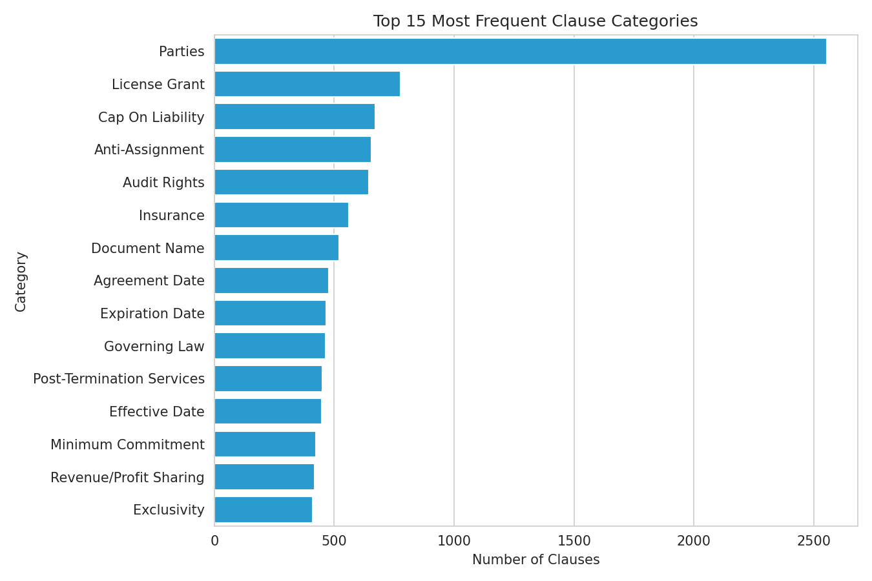
Fig 3.6 Top 15 most frequent clause categories in CUAD
The category distribution is highly uneven: “Parties” alone accounts for 2,554 of the 13,823 clauses (about 18%), followed by “License Grant”, “Cap On Liability”, “Anti-Assignment” and “Audit Rights”, each in the 600–800 range. This class imbalance, discussed further in Section 3.2.3, is a central design consideration for the modelling stage.
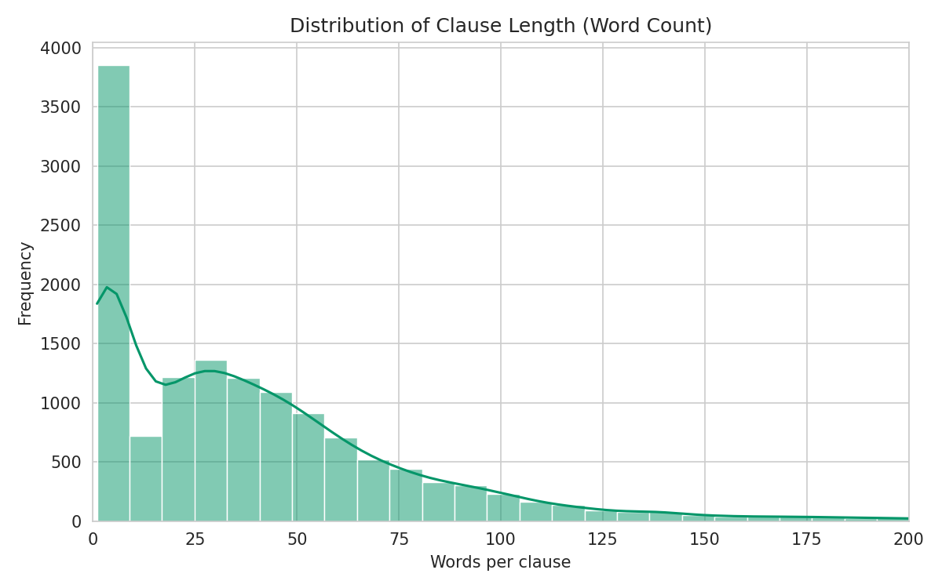
Fig 3.7 Distribution of clause length (word count)
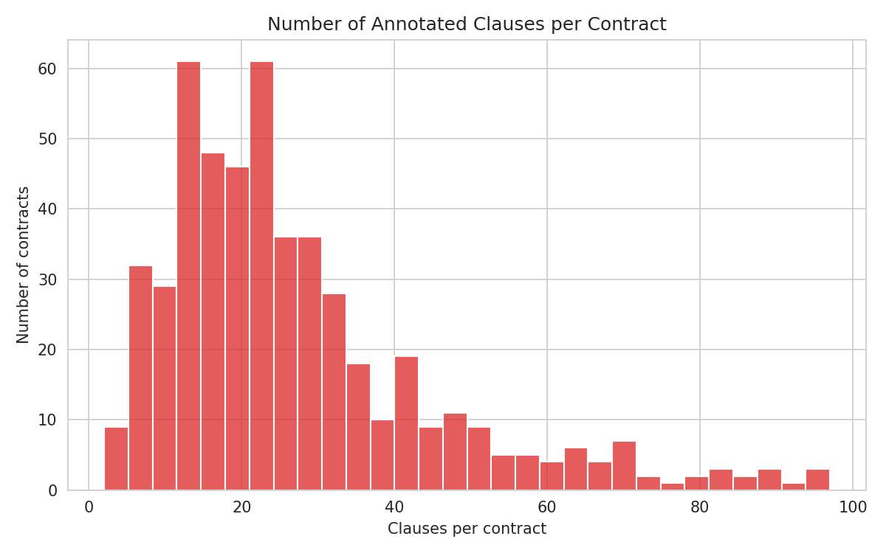
Fig 3.8 Number of annotated clauses per contract

3.2 Data Preprocessing

3.2.1 Data Cleaning
Two cleaning steps were applied to the flattened clause dataset before feature extraction:
- Text normalisation — collapsing repeated whitespace/newlines (a common OCR/formatting artefact in the source contracts) and stripping characters outside a legal-text-safe set (letters, digits, and common punctuation such as periods, commas, parentheses, %, $, and hyphens).
- Removal of extremely short spans — clause spans under 3 tokens (e.g. a lone party name or date fragment picked up as a partial answer span) carry little topical signal for a 41-way classifier and were removed.
def clean_text(t):
t = re.sub(r'\s+', ' ', str(t)) # collapse whitespace
t = re.sub(r"[^A-Za-z0-9.,;:()%$\-\s]", ' ', t) # strip odd artefacts
return t.strip()

df['clean_text'] = df['clause_text'].apply(clean_text)
df_clean = df[df['clean_text'].str.split().str.len() >= 3]
Before cleaning: (13823, 5)
Removed 1567 clauses with < 3 tokens (11.34%)

Cleaned dataset shape: (12256, 6)
Fig 3.9 Result of data cleaning and short-span removal

3.2.2 Analysis of Feature Variables
Clause text is converted into numerical features using Term Frequency–Inverse Document Frequency (TF-IDF) with unigrams and bigrams, a vocabulary capped at 5,000 terms, English stop-word removal, and a minimum document frequency of 2 (to discard one-off tokens such as OCR noise or party names).
tfidf = TfidfVectorizer(max_features=5000, stop_words='english',
ngram_range=(1,2), min_df=2)
X = tfidf.fit_transform(df_clean['clean_text'])
print('TF-IDF matrix shape:', X.shape)
print('Sparsity: {:.4f}%'.format(
100 * (1 - X.nnz / (X.shape[0]*X.shape[1]))))
TF-IDF matrix shape: (12256, 5000)
Sparsity: 99.5187%

Top 20 TF-IDF terms overall:
agreement 449.05
shall 394.78
party 353.97
term 211.92
company 203.05
date 171.49
section 160.32
written 158.05
right 153.40
license 144.56
Fig 3.10 TF-IDF feature matrix statistics and top terms
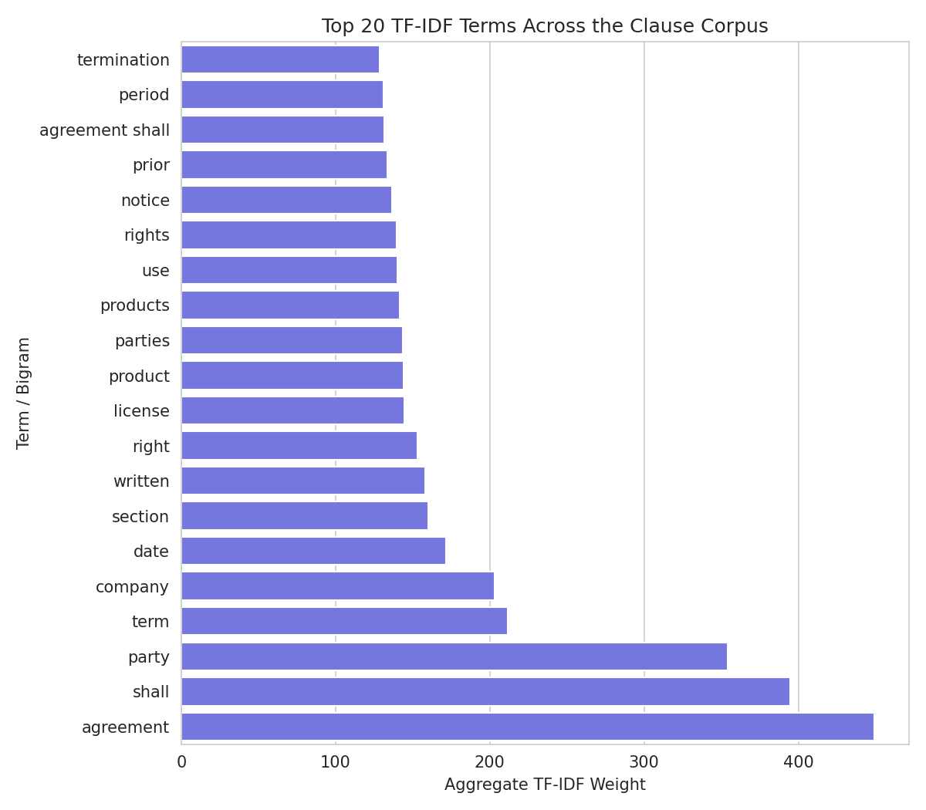
Fig 3.11 Top 20 TF-IDF terms across the clause corpus
As expected for legal text, the highest-weighted terms are boilerplate contract vocabulary (“agreement”, “shall”, “party”, “section”). These generic terms are shared across almost every category, so the classifiers must rely on more category-specific bigrams (e.g. “agreement shall”, “prior written”) and rarer discriminating terms to separate the 41 classes — this is one reason bigrams were included in the TF-IDF configuration rather than unigrams alone.

3.2.3 Analysis of Class Variables
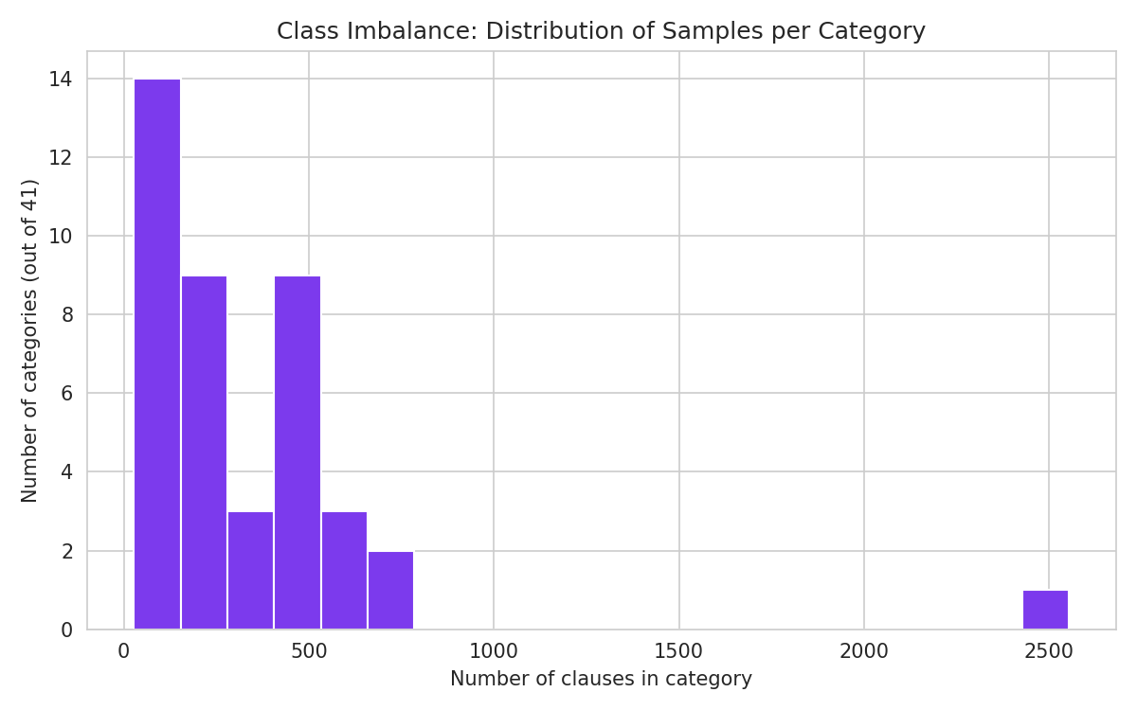
Fig 3.12 Class imbalance: number of categories by sample-count bucket
The 41 clause categories are strongly imbalanced. The largest class (“Parties”, 2,554 samples) has roughly 95 times more examples than the smallest class (“Price Restrictions”, 27 samples). Four categories fall below 40 samples after cleaning:
Categories with fewer than 40 samples:
Third Party Beneficiary 39
Most Favored Nation 38
Unlimited/All-You-Can-Eat-License 32
Price Restrictions 27
Fig 3.13 Rare categories identified for class-imbalance handling
Following the imbalance-handling strategy validated by Hasib et al. (2023) in Section 2, the modelling stage will address this imbalance using class-weighted loss (class_weight='balanced' in scikit-learn), stratified train/test splitting so every category is represented in both splits, and macro-averaged F1-score (rather than plain accuracy) as the primary evaluation metric, since accuracy alone would be dominated by the majority “Parties” class.

3.3 Data Visualization
The following visualisations summarise the shape of the CUAD-derived clause dataset used for ClauseIQ.
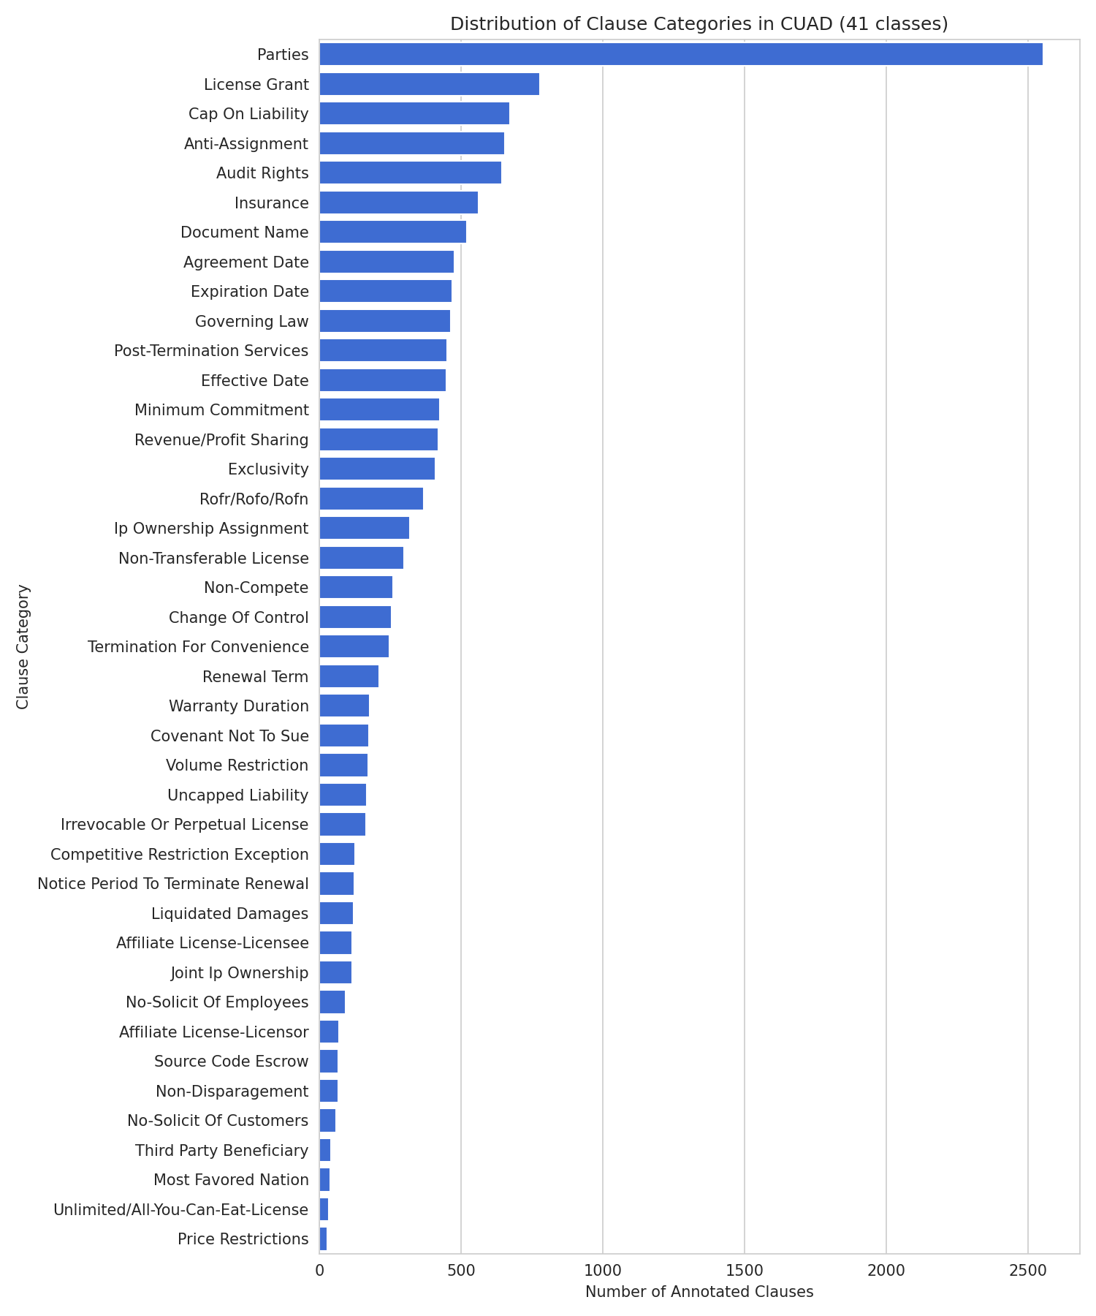
Fig 3.14 Full distribution of all 41 clause categories
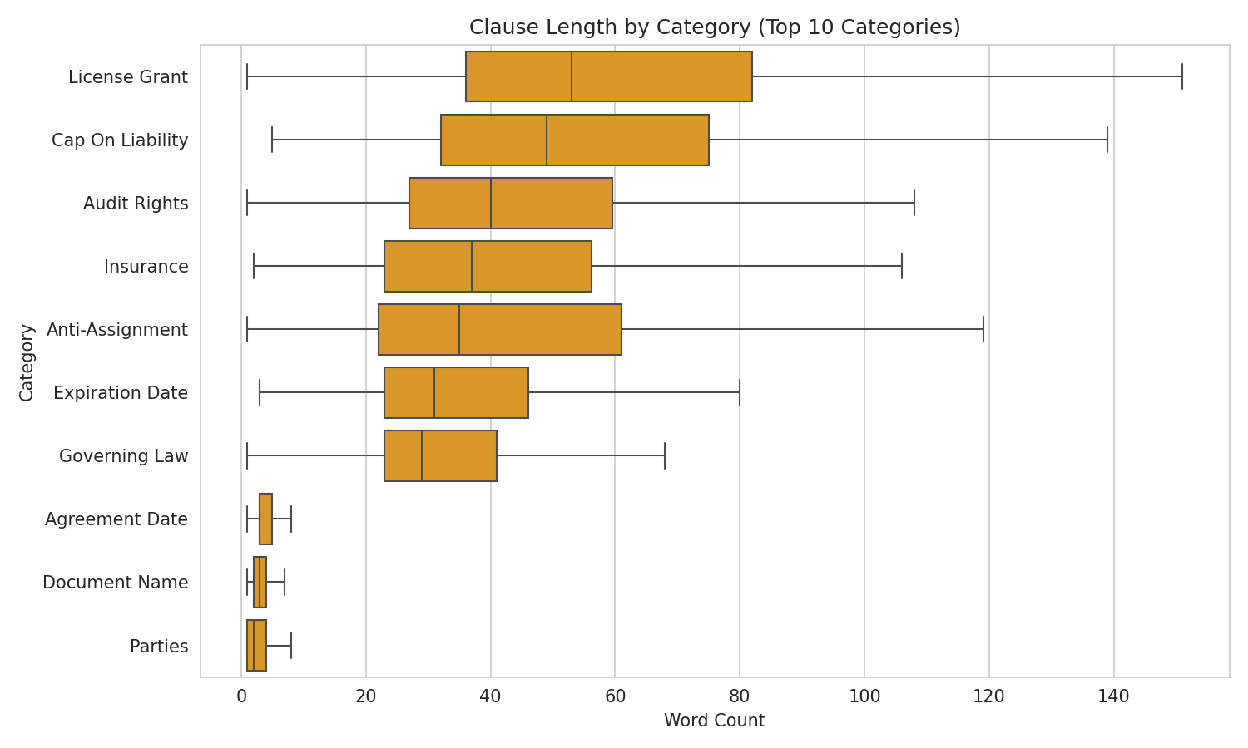
Fig 3.15 Clause length by category (top 10 most frequent categories)
Clause length also varies meaningfully by category — e.g. “Audit Rights” and “Insurance” clauses tend to be longer and more detailed than short factual spans such as “Agreement Date” — which is useful contextual information even though the primary features used for classification are TF-IDF weighted terms rather than length.
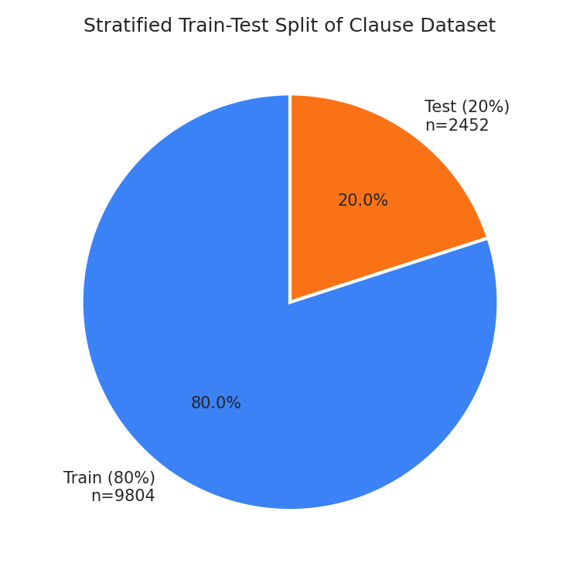
Fig 3.16 Planned stratified train/test split of the clause dataset
A stratified 80:20 train/test split (random_state = 42) is planned for the modelling stage so that every one of the 41 categories — including the rarest ones — is represented proportionally in both the training and test sets.

3.4 Analysis of Architecture and Algorithms

3.4.1 Detailed Study Report of the Proposed Algorithm(s)
ClauseIQ combines a TF-IDF feature representation with four classical supervised classifiers for clause categorisation, and a TF-IDF + cosine-similarity module for intelligent search over the same feature space.
TF-IDF Vectorisation
Term Frequency–Inverse Document Frequency converts each clause into a sparse numeric vector where each dimension corresponds to a term (unigram or bigram); a term's weight is high if it occurs often in that clause but rarely across the corpus, which surfaces category-discriminating vocabulary and down-weights generic boilerplate. TF-IDF is well suited to short, boilerplate-heavy legal clauses because it does not require the large labelled corpora that transformer embeddings need, and it produces an interpretable feature space (individual terms can be inspected, unlike dense neural embeddings).
Multinomial Naive Bayes
A probabilistic classifier that assumes feature (term) independence given the class. It is extremely fast to train, performs well on sparse high-dimensional TF-IDF matrices, and serves as a strong, simple baseline for multi-class text classification — the same role it plays as a baseline in Hasib et al. (2023).
Support Vector Machine (Linear Kernel)
SVMs find the maximum-margin hyperplane separating classes and are known to perform particularly well on high-dimensional, sparse text data such as TF-IDF vectors, where the number of features (up to 5,000) is much larger than what many other classifiers can handle efficiently. A linear kernel and one-vs-rest scheme are used to extend the binary SVM to the 41-class problem.
Logistic Regression
A linear probabilistic classifier trained with multinomial (softmax) loss, offering class probabilities (useful for ranking candidate categories, not just a single hard prediction) and good interpretability through per-class term coefficients, at low computational cost.
Random Forest
An ensemble of decision trees trained on bootstrap samples and random feature subsets, whose predictions are aggregated by majority vote. Random Forest can capture non-linear interactions between TF-IDF features and is naturally robust to noisy or irrelevant terms, at the cost of higher memory use on very high-dimensional sparse input.
Cosine Similarity (Intelligent Search)
For the search module, both the corpus of clauses and an incoming natural-language query are projected into the same TF-IDF space, and clauses are ranked by the cosine of the angle between their vector and the query vector. Cosine similarity is scale-invariant (it is unaffected by clause length) and is the standard similarity measure for sparse bag-of-words / TF-IDF retrieval, which is why it was selected over Euclidean distance for this task.
Justification (from Section 2 literature)
- Hasib et al. (2023) show classical ML classifiers (Naive Bayes, SVM, Logistic Regression) remain competitive on imbalanced multi-class text classification once class-imbalance handling is applied — directly supporting their use as ClauseIQ's baseline models on the imbalanced CUAD categories.
- Siino et al. (2025) confirm that TF-IDF-based classical pipelines are an established, interpretable starting point in legal NLP before moving to transformer-based approaches, matching ClauseIQ's phased, scope-controlled strategy.
- Wang et al. (2024) demonstrate the value of pairing a retrieval/search component with a classification component for legal text systems, which motivates ClauseIQ's dual classification + cosine-similarity-search design.
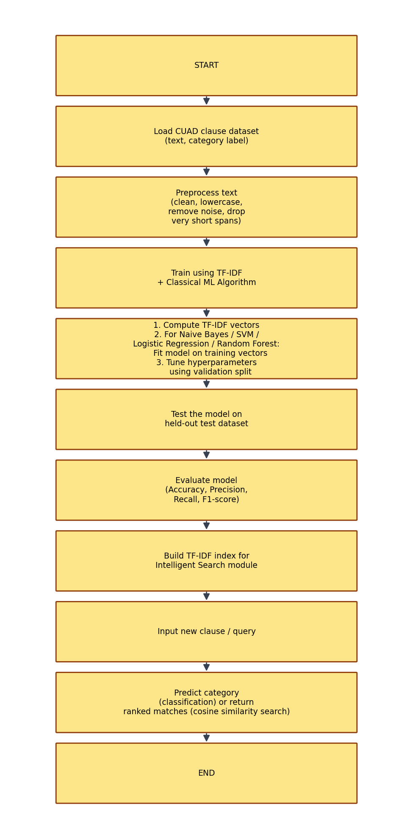
Fig 3.17 Activity diagram: TF-IDF + classical ML clause classification and search pipeline
Pseudocode: TF-IDF + Classifier Training
Input: Clause dataset D with text X and category labels Y (41 classes)
Output: Trained classifier + fitted TF-IDF vectorizer

function TRAIN_CLAUSE_CLASSIFIER(D, model_type):
X_clean <- CLEAN_TEXT(D.text)
tfidf <- FIT_TFIDF(X_clean, max_features=5000, ngram_range=(1,2))
X_train, X_test, y_train, y_test <- STRATIFIED_SPLIT(tfidf, D.category, test_size=0.2)
model <- INIT_MODEL(model_type, class_weight='balanced') # NB / SVM / LR / RF
model.fit(X_train, y_train)
y_pred <- model.predict(X_test)
metrics <- EVALUATE(y_test, y_pred) # macro-F1, per-class F1, accuracy
return model, tfidf, metrics

function SEARCH_CLAUSES(query, corpus_vectors, tfidf, top_k):
q_vec <- tfidf.transform([query])
scores <- COSINE_SIMILARITY(q_vec, corpus_vectors)
return TOP_K_RANKED(scores, top_k)

3.5 Project Pipeline

3.5.1 Project Pipeline Diagram with Explanation
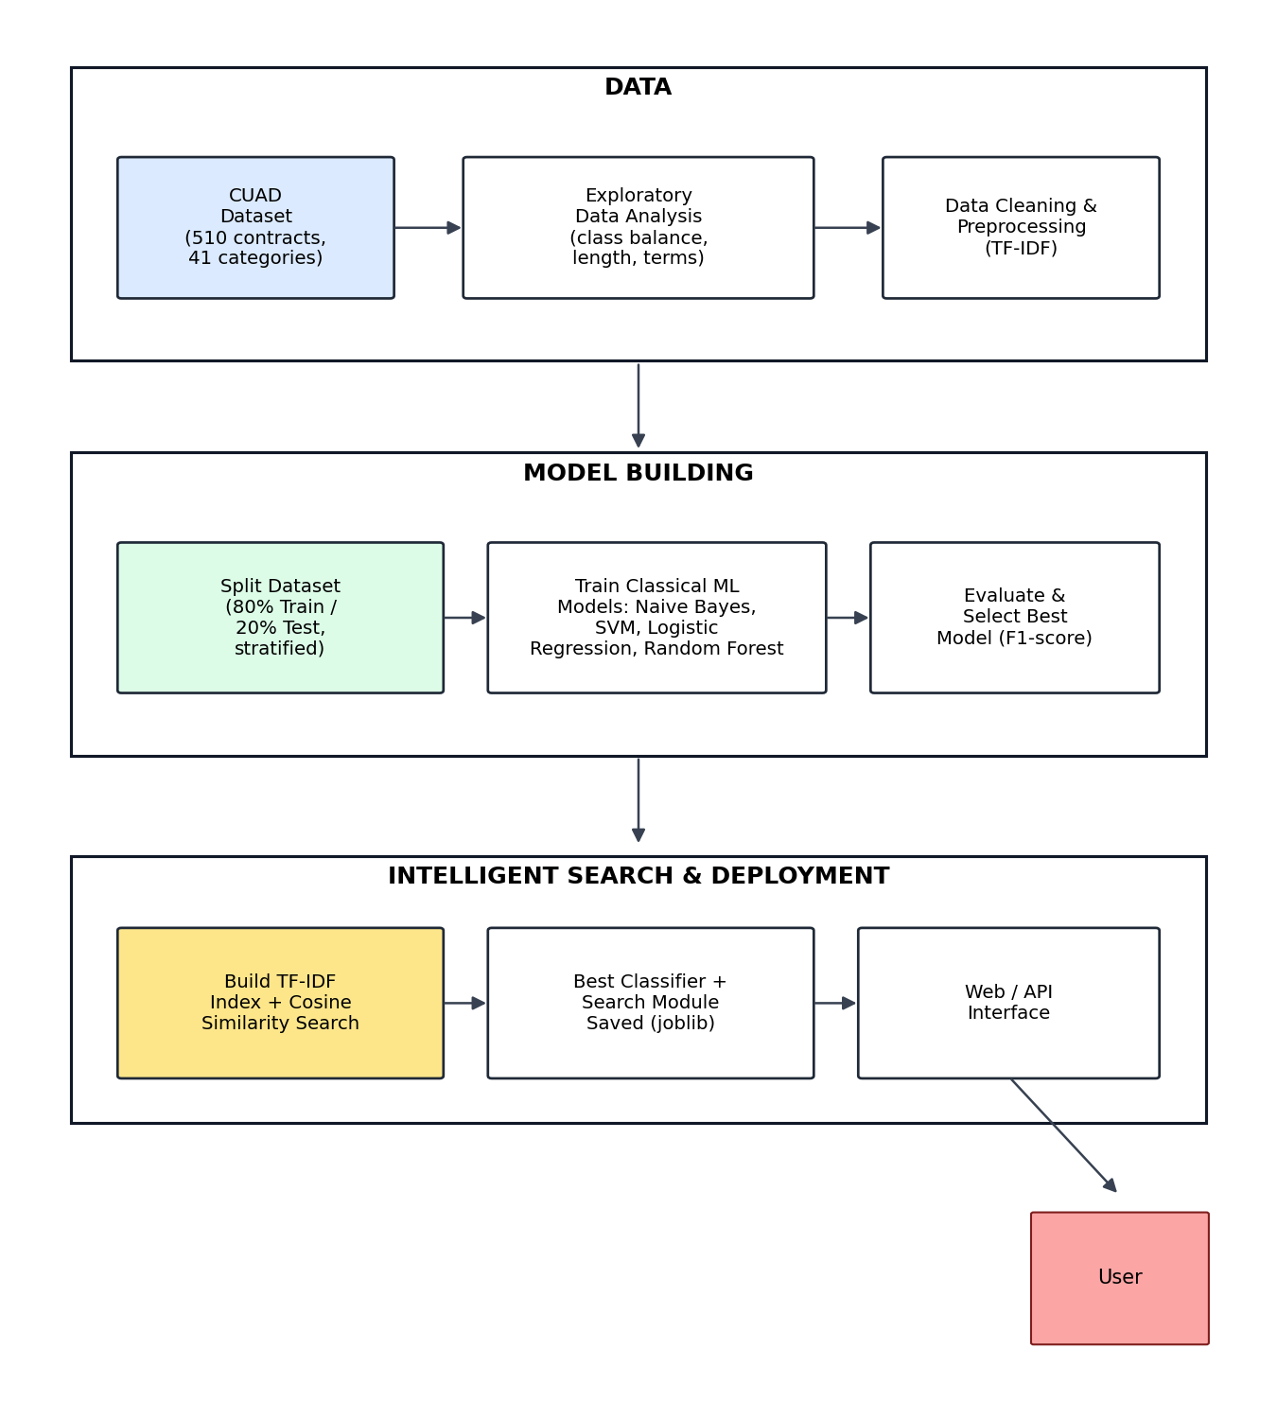
Fig 3.18 ClauseIQ project pipeline
Data
The pipeline begins with the CUAD dataset (510 contracts, 41 clause categories), which is flattened from its SQuAD-style JSON format into a clause-level table as described in Section 3.1. Exploratory data analysis (class distribution, length distribution, missing-value and duplicate checks) is performed to understand the corpus, followed by data cleaning and TF-IDF-based preprocessing as described in Section 3.2.
Model Building
The cleaned, vectorised dataset is split into stratified training (80%) and testing (20%) subsets. Four classical ML models — Multinomial Naive Bayes, Linear SVM, Logistic Regression and Random Forest — are trained on the TF-IDF features with class-weighting to address the imbalance documented in Section 3.2.3, and compared using macro-F1, per-class F1 and accuracy to select the best-performing classifier.
Intelligent Search & Deployment
Independently of classification, a TF-IDF index of the full clause corpus is built to support cosine-similarity-based intelligent search: a free-text query is vectorised in the same TF-IDF space and the most similar clauses are ranked and returned. The selected classifier and the search index are planned to be persisted (via joblib) and exposed through a simple web/API interface so a user can classify a new clause or search the corpus for clauses matching a natural-language query.

3.6 Feasibility Analysis
Feasibility has been assessed across technical, economic and operational dimensions, consistent with the scope-controlled, classical-ML approach agreed with the project guide.
3.6.1 Technical Feasibility
- Data processing: CUAD is a public, well-documented, CC-BY-4.0-licensed dataset; it was downloaded directly from the official GitHub repository and successfully flattened into a clean, tabular clause dataset (13,823 rows) using standard Python libraries (pandas, json, re), confirming that data acquisition and preprocessing are fully achievable within the project's technical resources.
- Machine learning: TF-IDF vectorisation and the four chosen classifiers (Naive Bayes, SVM, Logistic Regression, Random Forest) are all implemented in scikit-learn, a mature, well-documented, free library; no custom low-level ML code or GPU hardware is required.
- Search module: cosine similarity over TF-IDF vectors uses the same scikit-learn feature space already built for classification, so no additional infrastructure (e.g. a dedicated vector database) is required at this project's scale (13,823 clauses).
- Deployment: the trained classifier and TF-IDF index can be serialized with joblib and served through a lightweight Python web framework (e.g. Flask), consistent with tooling already used elsewhere in the department's mini projects.
3.6.2 Economic Feasibility
- All software used — Python, pandas, scikit-learn, matplotlib/seaborn, Flask, joblib — is free and open-source; the CUAD dataset itself is free and openly licensed (CC BY 4.0).
- No paid annotation, cloud GPU, or third-party API costs are required for the classical ML approach adopted here, keeping the project's running cost close to zero beyond standard computer hardware and development time.
- The resulting tool has clear practical value — faster clause triage for legal/compliance teams, students, and paralegals reviewing standard commercial contracts — which justifies the (minimal) development effort.
3.6.3 Operational Feasibility
- End users (e.g. a paralegal or contract reviewer) only need to paste clause text or a search query into a simple web interface; no legal-technology or machine-learning expertise is required to operate the system.
- Because the underlying models are lightweight classical classifiers rather than large neural networks, inference is fast enough for interactive, single-clause or single-query use on ordinary hardware, without needing a GPU or specialised serving infrastructure.
- The system's scope is intentionally bounded to the 41 CUAD categories and to classical ML, which keeps the operational surface small and maintainable within a single-semester mini project timeline, while leaving a clear, well-justified extension path (transformer / RAG-based deep learning) for a future main project.

